Media pack for advertisers

African Arguments is the Royal African Society’s well-regarded pan-African magazine. It publishes high quality news analysis, opinion and investigative journalism.

Contributors include leading politicians and diplomats; award-winning commentators and journalists; and thought leaders from business to civil society to culture. A few recent high-profile writers and interviewees include:

- Hakainde Hichilema, Zambia’s main opposition leader
- Carlos Lopes, former Executive Secretary of the United Nations Economic Commission for Africa
- Olusegun Obasanjo, former President of Nigeria
- Zainab Bangura, former United Nations Special Representative on Sexual Violence in Conflict and Sierra Leone Foreign Minister
- Moïse Katumbi, Democratic Republic of Congo’s main opposition leader

Our articles are republished in several outlets, including:
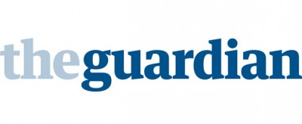

We have received grants from foundations, including:

Key stats
- 100,000 unique users per month on site
  - 45% Africa; 25% Europe; 25% Americas

- 60,000 followers on social media
  - 4.6 million impressions per month on Twitter
  - 100,000 reach per month on Facebook
  - 12% aged 18-24; 57% aged 25-34;
18% aged 35-44; 13% aged 45+

- 7,000 newsletter subscribers

- 300+ contributors (two thirds of whom are African)

- 50% mobile traffic

Rates
- Billboard (970x250px) £1,500 per month

- Leaderboard (728x90px) 1,200 per month

- Double MPU (300x500px) £900 per month

- MPU (300x250px) £600 per month

For further information, please contact:
James Wan
Editor, African Arguments

editor@africanarguments.org | +44 203 073 8338

